How to run reports for Cash/Travel Advances

Note: Only a limited number of people have access to run these reports. At least one person in each college/division has been given access.

You can run the following Concur Reports to obtain a list of all Cash/Travel Advances (with corresponding TRs and Expense Reports if applicable) or to identify outstanding Cash/Travel Advances with remaining balances that need to be cleared:

Cash/Travel Advances – List of all Cash /Travel Advances
This report will generate a list of all Cash/Travel Advances with corresponding TRs and Expense Reports, if applicable.

Outstanding Cash/Travel Advances (with remaining Cash/Travel Advances to be cleared)
This report will generate a list of outstanding Cash/Travel Advances with remaining balances that need to be cleared.

- Go to Reporting>Intelligence

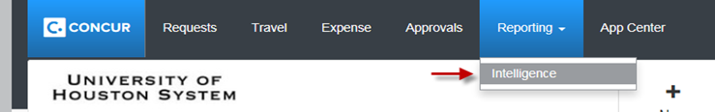

- Click on the “University of Houston System” folder.
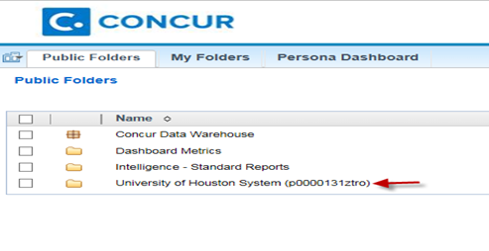

- Click on the “User Reports” folder.

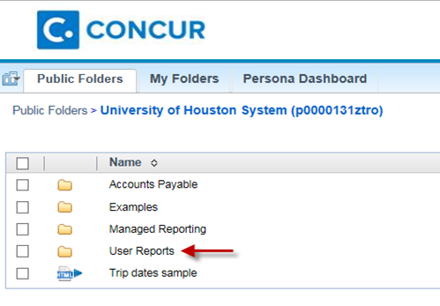

- Click on the report that you want to run.

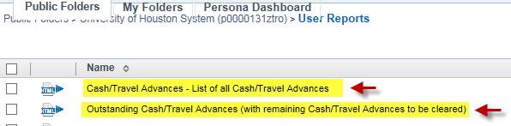

- You will see the screen listing the report result. To generate the report in Excel format, click on and select an appropriate “View in Excel” option. Review the results of both reports.

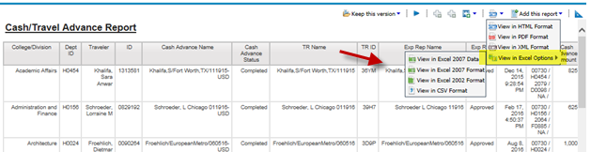

Note: Concur Reports pulls the information as of the previous day. Therefore, if you run the above reports today, you will see the results listed as of yesterday.

